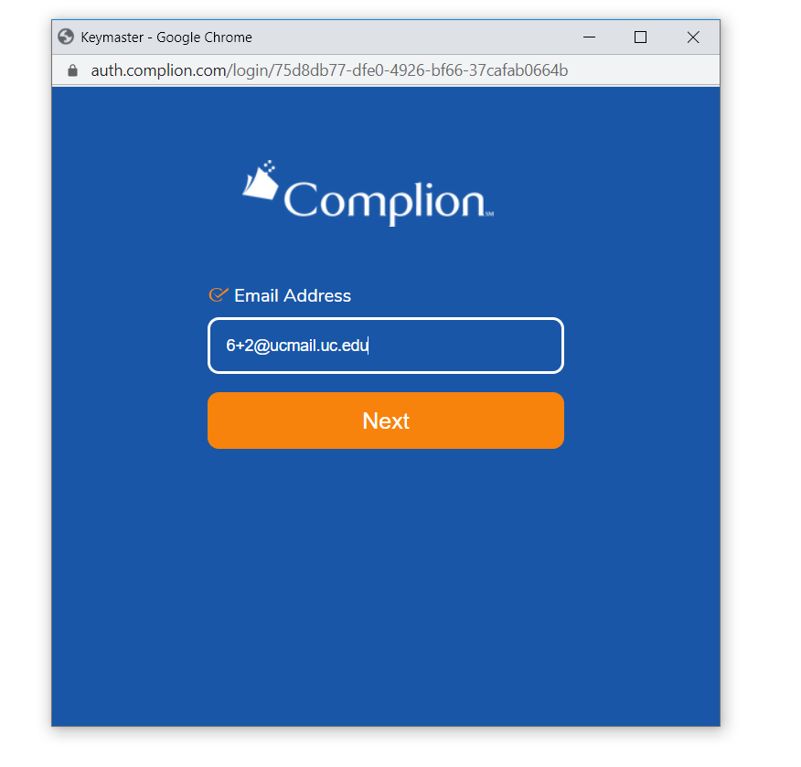How to sign off on the Delegation of Authority Log:

Step 1B: Please follow the link and login to Complion. Your login information will typically consist of your UC 6+2 proceeded with @ucmail.uc.edu. If you are unable to login please contact the Regulatory CRP assigned to the study you are working on and they will assist you.

Step 1: you will receive an e-mail for your Regulatory CRP stating that the DOA log is complete and your tasks/rolls are ready for your review and signature.

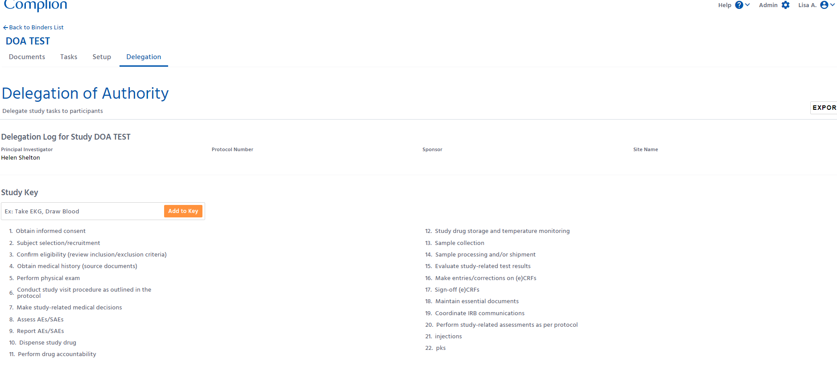

Step 2: If you followed the link sent to you, you will then be automatically directed to the DOA log associated with that link.

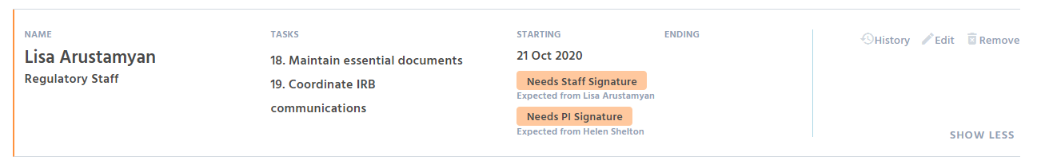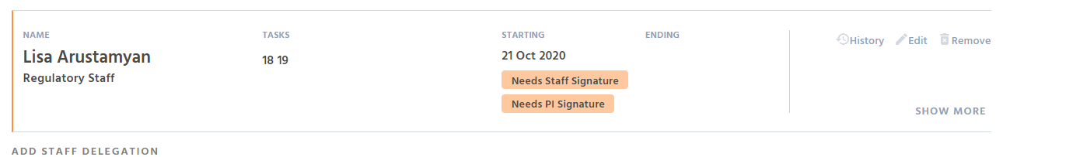

** Please note to review your tasks, simply click the ‘needs staff signature’ box and the tasks associated with the task numbers will populate

Step 2C: Please then review your tasks and confirm they are applicable to your roll on this study. If they are not or need to be correct please let your Regulatory CRP know as soon as you notice the discrepancy.

Step 2B: Please scroll down until you see your name,

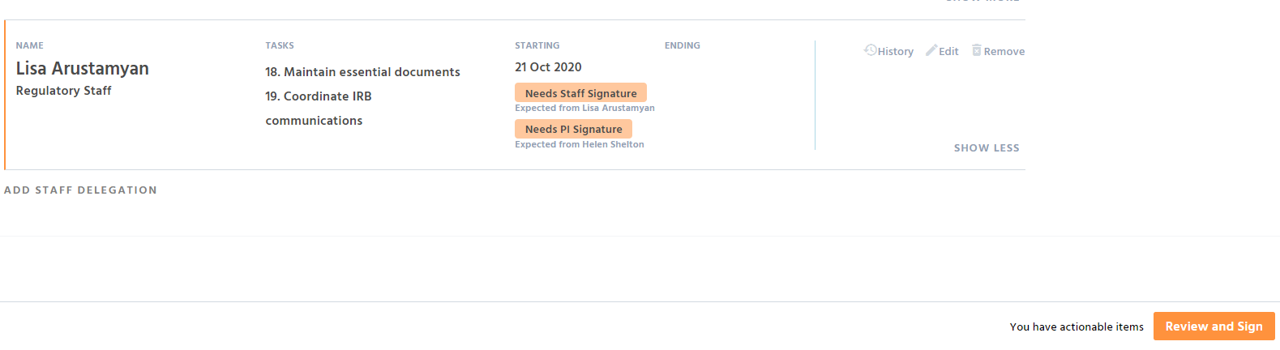

Step 3: Once you review your tasks you will find a ‘Review and Sign’ tab at the bottom of your screen. Please click the tab

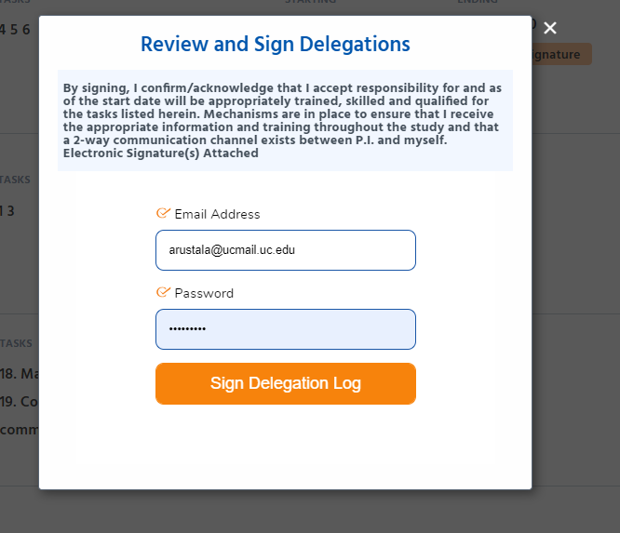

Step 3B: Once you click the ‘Review and Sign’ tab a Review and Sign Delegations will populate. Please review the statement. This statement and 2 part sign-off complies with the FDA 21 CFR Part 11 requirements for signature.

Step 3C: Once you sign, your name on the delegation will appear as such:

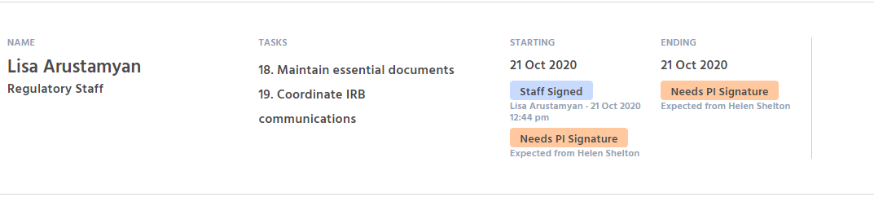

The task has been completed and you have now officially signed off on the DOA log for this study!

**Congratulations!**

**Please note that once you have signed the delegation log the following blue notification will appear at the bottom of your screen.

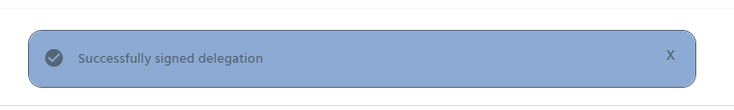

Once all signatures have been received the Regulatory CRP will extract the delegation log and file it in the E-Regulatory Binder for this study. The DOA log will be available for sponsor/study team review and can be extracted/printed at any time.