Steven Goldman Memorial
Pancreatic Cancer
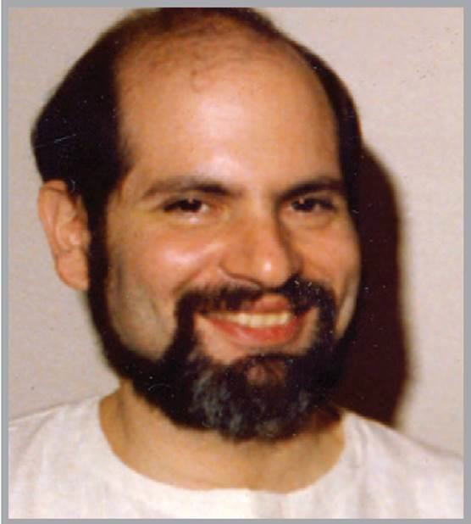
Research Grant

Important Deadlines
Call for Applications May 1, 2021
Deadline for Applications June 1, 2021
Awards announced and funds available by August 1, 2021

Introduction
The Steven Goldman Memorial Pancreatic Cancer Research Grant was created to honor the memory of Steven Goldman who lost his battle with pancreatic cancer in 1985. This grant award in his name is reserved for scientific researchers of the highest caliber who are dedicated to eradicating pancreatic cancers.

Purpose
The purpose of this grant is to encourage research in the any of the following areas; clinical/ translational research in adult pancreatic cancer, molecular genetics of cancer, tumor immunology, growth promoting factors of cancer, tumor virology that appears to have relevance to human cancers and other areas such as population science.

Goals
The goals of the Steven Goldman Memorial Pancreatic Cancer Research Grant are to encourage:
- Clinical and translational research in the area of cancer;
- Basic research in the area of cancer;
- Projects seeking to determine the cause of cancer;
- Projects that study the mechanisms by which cells undergo malignant transformation;
- Study of the failure of the host to stop the spread and progression of the cancer

Award
The Steven Goldman Pancreatic Cancer Research Grant will offer a total award of $54,000 to support one outstanding application. The grant will be awarded for the period of one year. Grant recipients are eligible to apply, as a renewal for no more than 3 years, and renewal applications will be in competition with new applications for funding.

Eligibility
The investigators must be a full-time basic scientist affiliated with the University of Cincinnati and must be of high moral and scientific integrity. Preference is to be given to investigators who have made a full-time career commitment to basic cancer research and those investigators whose work involves or relates to cancer of the pancreas. The grant shall be distributed to an individual investigator and may not be divided up among two or more investigators. The investigator to whom the award is made may use part of the award to hire or pay lab staff or postdoctoral fellow, provided that the individual is working under the direction of the funded investigator and his or her work must be restricted to the funded cancer research project. No more than 10% of the award may go to administrative expenses; the remainder of the award must be given to the investigator to be spent entirely on the research project for which the award is made.

This grant will not support:
- Patient care or caring for the families with relatives who have cancer
- Screening of presumed or questionable carcinogens in various animal or cell models
- Improving current modalities of cancer treatment such as better surgical techniques
- Testing of new chemotherapeutic agents
- The purchase of cellular devices
- More than 10% of administrative costs

Review of Applications
Please submit a 6-page full application using the criteria below. Applicants will undergo rigorous peer-review by the UCCC Grant Selection Committee for final decision. Reviews will be scored in accordance with NIH grant review guidelines.

Applications
The following items must be submitted for an application to be considered complete and eligible for review.
- UCCC Coversheet (Please see required template)
- Abstract: Explain why this work is important (Not to exceed 250 words in Arial 11-point font)
- Project Narrative: The narrative is limited to a maximum of 6 typewritten pages (excluding references) in no less than Arial 11-point font. All text, tables and figures must be included in the body of the application and no appendices will be accepted other than appropriate letters of support. Included in the narrative should be background, hypothesis and specific aims, preliminary data (not mandatory), experimental design and a timeline of the study plan including submission to IRB and other appropriate review committees.
- References
- Budget: The budget should include only items needed to perform the project. PI’s salary, cellular devices, capital equipment, indirect costs or administrative services may not be included. Exceptions may be made if a proven need exists. Any purchase of electronics (i.e. computers, laptops, tablets, etc.) belong to the University and must be relinquished to the UCCC Grants Office at the closing of the grant or expiration of funding. Please see the UCCC Grants Policy for more information. Salary of postdoctoral fellow or research staff relative to the effort on the project may be included. Projects are limited to a maximum of $54,000 for one year. See eligibility sections for additional information. The budget should be submitted in PHS-398 format: http://grants.nih.gov/grants/funding/phs398/fp4.pdf
- Budget Justification: The budget justification is a separate document from the budget and must itemize and explain all items directly related to the research project.
- Biographical sketch of the PI and Co-Investigators current curriculum vitae in PHS-398 format NOTE THE NEW BIOSKETCH REQUIREMENTS EFFECTIVE MAY 25, 2021 https://grants.nih.gov/grants/guide/notice-files/NOT-OD-21-073.html Access the instructions and blank form here https://grants.nih.gov/grants/forms/biosketch.htm
- Other Support: All project investigator’s active and pending sources of research support. Access the new OTHER SUPPORT Document here: https://grants.nih.gov/grants/forms/othersupport.htm

For investigators moving into new, innovative areas of work, the absence of preliminary data will not preclude funding. The role of the presented project in leading toward successful extra-mural funding should be addressed. In addition, selected PIs will have an opportunity to present their study findings at a UCCC Center & Program Leadership Meeting. Please see the UCCC Grant Policy for details.

Progress Report
The investigators who receive funding will be expected to provide a detailed progress report every 6 months for the duration of funding and annually for up to 5 years post award so any subsequent funding and/or publications can be captured. Progress reports should include status of project and any abstracts, publications, or secondary funding generated from this award. The template required for each report will be provided to awardees. Timely submission of progress reports is required for the continuation of funding. Additional progress reports (written or in person) may be requested by the donor and will be coordinated with the investigator in advance.

Discontinuation of Funding
In the event the Steven Goldman Memorial Pancreatic Research Grant’s Principal Investigator (PI) leaves the University of Cincinnati Cancer Institute, uses the grant award for research not within the guidelines of the grant award, or if no substantive progress has been made within 12 months on the project, the UCCC reserves the right to rescind the remaining grant money available to the PI. Review and decision will be made on a case-by-case basis. In the instance funding is rescinded, the funds will be reinvested into the Steven Goldman Memorial Pancreatic Cancer Research endowment fund.

Please submit electronic version of Application to the UCCC Grants Coordinator at UCCCgrants@uc.edu.

